## Dot matrix display

1. Learning objectives

By learning to use STM32F103RCT6 and 8*16 dot matrix modules, you can implement dot-matrix driven writing, and finally display the content you want.

1. Prepare before class

Connect the STM32 chip with the 8*16 dot matrix module for wiring diagram:

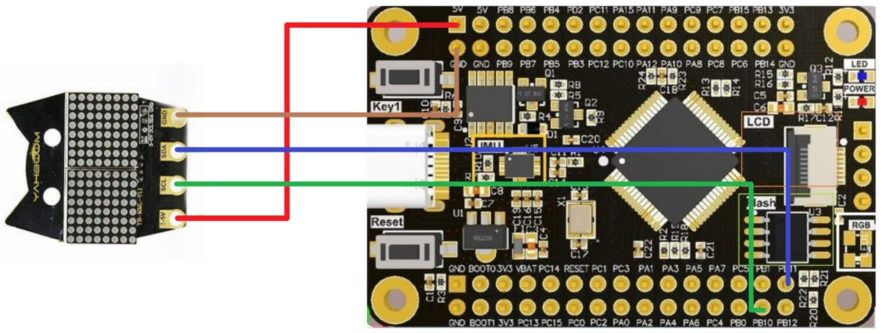

|  |  |
| --- | --- |
| Dot matrix module | STM32F103RCT6 |
| VCC | 5V |
| PB10 | SCL |
| PB11 | SDA |
| GND | GND |

1. Programmatic

keil programming: first of all, we will use st-link as a downloader, we need to press the four connectors of st-link to connect the corresponding pin above STM32F103RCT6, then open keil, click the magic wand to select debug and select the corresponding downloader such as st-link, and then click settings to appear This interface can be downloaded normally.

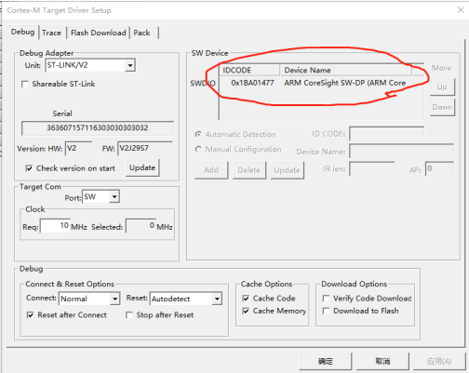

1. initialize

External clock initialization：

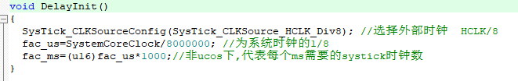

HT16K33 initialization：

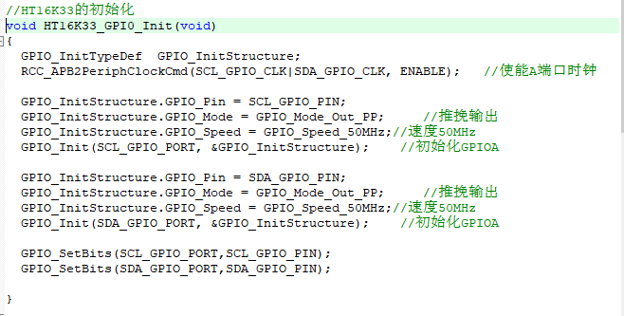

The display shows reset：

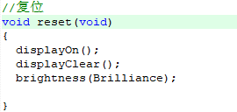

Display functions：

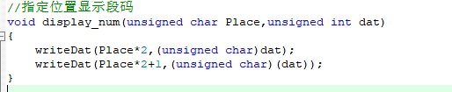

1. Take the mold

First of all, you can download the PCtoLCD modeling software, which is also available in the information we provide

The first step is to unzip and open the .exe software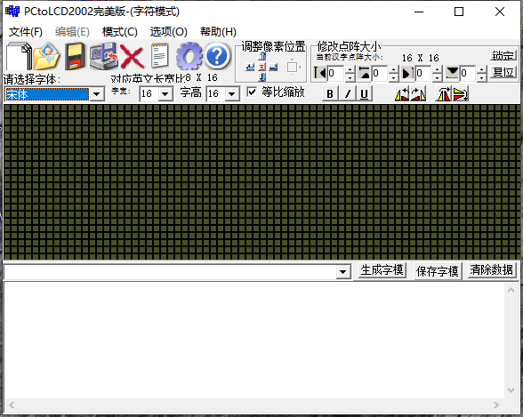

Step 2: Create a new image, select the size of your own dot matrix, select 8*16 here, and click Confirm

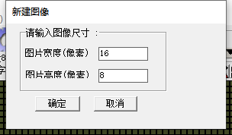

The third step is to set the relevant parameters, open the settings, and change them to the following

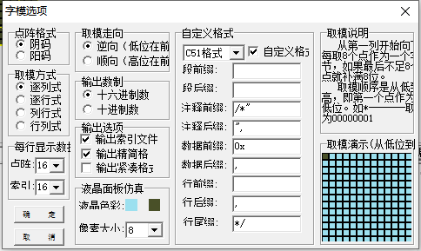

Step 4: Draw your favorite pattern, click Generate Font Mold, and copy it.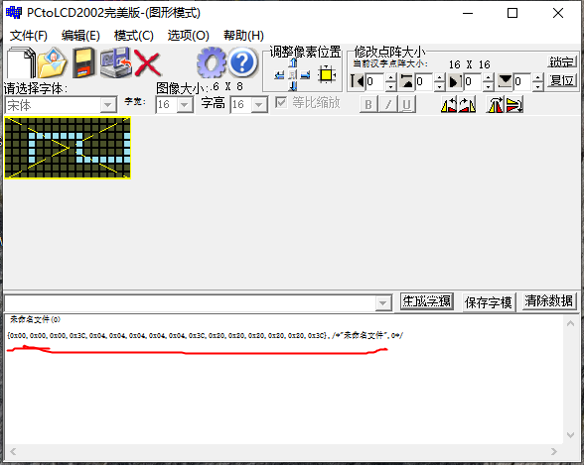

1. Main function

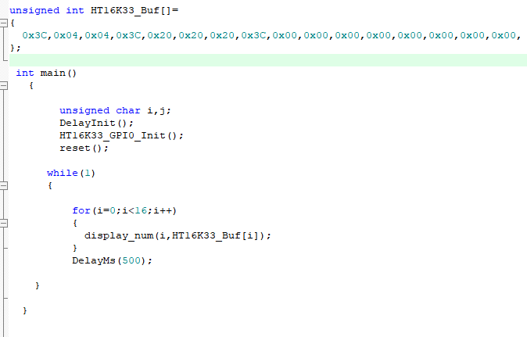

Paste the font mold you just copied into the HT16K33_BUF array, and then use the display_num function to display the pattern you draw.

1. effect

